Develop Coalitions Domain Assignment

Assignment Overview
For this domain assignment, you will complete a Partnership Analysis. In your Partnership Analysis, you will analyze what each stakeholder values, stands to gain or lose, and contributes to the project or organization.

In order to complete the assignment components below, you will need to refer back to the Purposely Build Partnerships & Networks to Create Results capability where you identified a project initiative and completed a Stakeholder Map. You will also need to refer to the Stakeholder Assessment (including the Stakeholder Matrix and stakeholder perspective questions) that you completed in the Navigate Sociopolitical Environments capability).

Take a moment to review the assignment rubric, before beginning your assignment.

For this assignment, you will submit the following using the Partnership Analysis Template below:
- Partnership and Project Summary
- Stakeholder Map
- Stakeholder Assessment (matrix and perspectives questions)
- Insights

1. Project Summary
Add important context and background to your Partnership Analysis by writing a short summary (350 words or less) below of the project initiative that you have identified, and the desired outcomes of the project.

2. Stakeholder Map
Plot the names of the partners and stakeholders that you have identified on the map below.

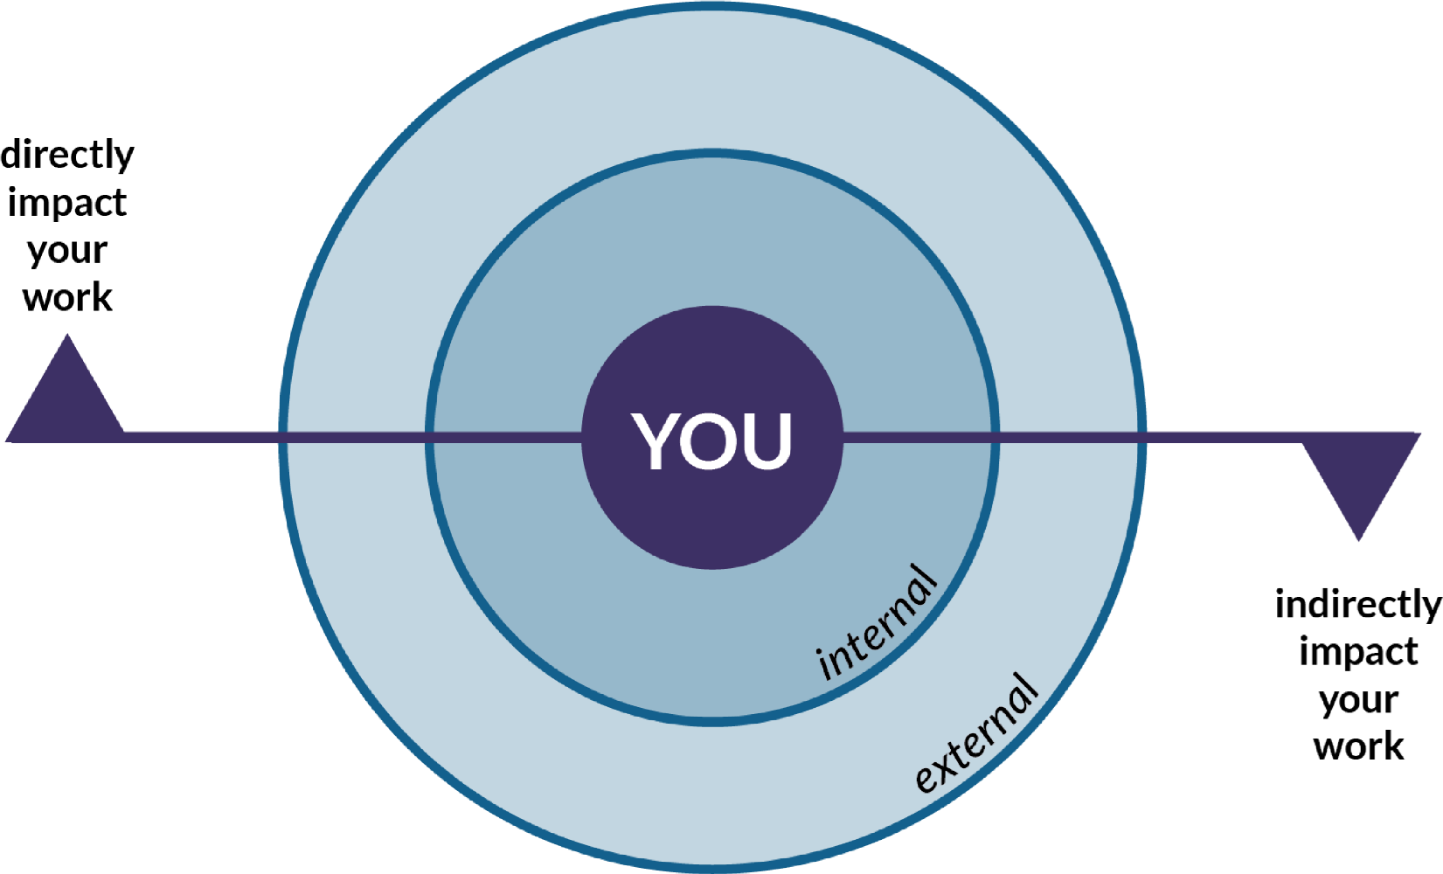

3. Stakeholder Assessment

A) Stakeholder Matrix

Plot the stakeholders in the appropriate quadrants below to create a Stakeholder Matrix
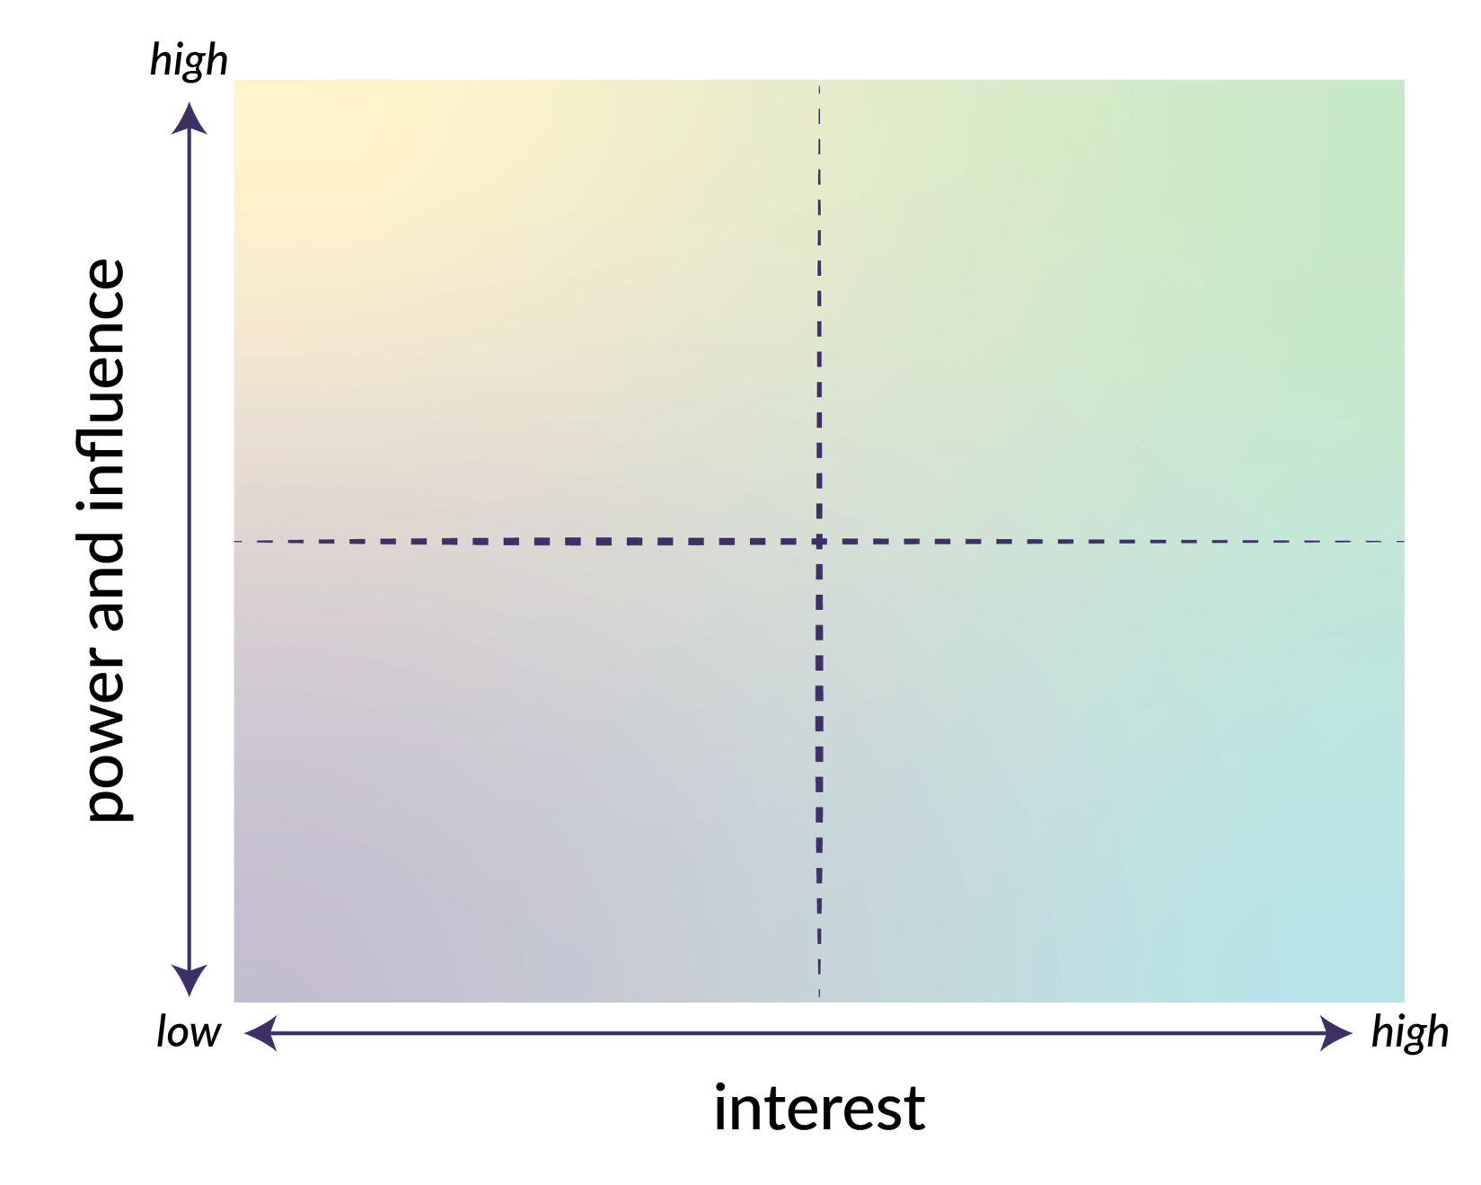

B) Stakeholder Perspective

Review your list of key stakeholders from the upper right quadrant. Starting with your own organization, answer the questions below to discern the differences in perspectives from all the members of that quadrant. Next, complete the same exercise for the other three quadrants for a full stakeholder assessment. If you are unable to ask the stakeholders these questions firsthand, you may place yourself in each stakeholder’s shoes to respond to the questions.

- What values does the stakeholder hold?
- What loyalties does the stakeholder have?
- By being a part of this coalition, what are the potential gains for the stakeholder?
- By being a part of this coalition, what are the potential losses for the stakeholder?
- What value does the stakeholder bring to this collaborative effort?

4. Insights
Analyze the information you gathered from completing the Stakeholder Map and Stakeholder Perspectives and answer the questions below (approximately 150 words per question).

- How does the information you gathered challenge your current behaviour? How will it change?
- How did your organization’s values conflict with those of your stakeholders? How will you navigate this conflict?
- After completing the activities, what did you find most challenging about the process of analyzing your stakeholders?
- What were significant “a-ha” moments you had during the process?
- Place yourself in the shoes of your stakeholders. What are elements beyond values and contributions that they should know about your organization? What knowledge will enable them to work better with you?

